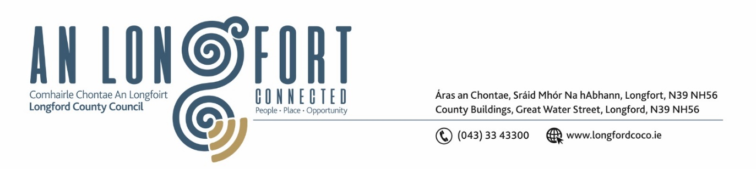

**GRANARD MUNICIPAL DISTRICT**

**Minutes of Meeting of Granard Municipal District**

**held in the Council Chamber and via Microsoft Teams**

**on Tuesday, 24 October 2023 at 3.30pm**

**CATHAOIRLEACH**: Councillor Turlough McGovern

**MEMBERS PRESENT**: Councillors – Paraic Brady, Garry Murtagh, PJ Reilly and

Colin Dalton

**IN ATTENDANCE**: Ms. Barbara Heslin, Director of Services

Mr. John McKeon, Head of Finance

**APOLOGIES** None

**MEETINGS**

**ADMINISTRATOR**: Ms Claire McNabola

1. **CONSIDERATION OF 2024 GENERAL MUNICIPAL ALLOCATION**

John McKeon, Head of Finance gave a comprehensive presentation regarding the General Municipal Allocation 2024 under the following headings and replied to queries raised –

* Budgetary Process – under Local Government Reform Act 2014
* Local Property Tax Variation – retain rates for 2023 and 2024
* Source of Funding for Municipal District
* Acute Financial Challenges for 2024
* No scope to increase local income
* Lowest valued LPT base in Country, maxed at 15%
* Ukrainian Humanitarian Crisis
* Members increased rates for 2023
* Local Election Year 2024
* Largest % population increase in the state
* Downward revaluations for Utility Providers
* New service initiatives only part funded
* Inflationary Pressures
* Ever increasing demands for match funding for Capital Projects
* Uisce Eireann Standard Costs
* Fire Service Costs
* Coats for providing services for Multiple Departments
* Rent Review
* Potential Deficit for 2023
* Recruitment Costs
* General Municipal Allocation 2024 Recommendation - €100,000 to be distributed as follows – Community Grants - Tidy Town Grants - Town Twinning – Dring Car Park – Special Project Grants – Christmas Lights – BCP’S
* Granard MD 2023 GMA Committed to date – 96 Groups received funding
* Governance

**Granard GMA Sub-Service Allocation 2024**

|  |  |  |  |  |
| --- | --- | --- | --- | --- |
| **Service Division** | **Sub-Service** | **Allocation 2023** | **Suggested Allocation 2024** | **Increase/Decrease** |
| **Balance B/F** |  |  | **€2,540** | **€2,540** |
| **Recreation & Amenity** | **Town Twinning** | **€6,000** | **€7,000** | **€1,000** |
| **Recreation & Amenity** | **Voluntary Bodies Grants** | **€43,086** | **€48,210** | **€5,124** |
| **Recreation & Amenity** | **Tidy Towns/Development Committees** | **€8,664** | **€10,000** | **€1,336** |
| **Recreation & Amenity** | **Dring Car Park** | **€2,000** | **€2,000** | **€0** |
| **Recreation & Amenity** | **Special Project Grants** | **€25,000** | **€25,000** | **€0** |
| **Recreation & Amenity** | **BCP** | **€1,250** | **€1,250** | **€0** |
| **Recreation & Amenity** | **Christmas Lights** | **€4,000** | **€4,000** | **€0** |
| **Grand Total** |  | **€90,000** | **€100,000** | **€10,000** |

The members thanked John for the presentation and acknowledged all the groups that received funding in 2023 and complimented these groups for the works that they did in the community. They also complemented and thanked the team in Community that administered the scheme.

On the proposal of Councillor PJ Reilly, seconded by Councillor Garry Murtagh the General Municipal Allocation for 2024 was adopted.

This concluded the business of the meeting.

**Signed: ____________________**

**Claire McNabola**

**Meetings Administrator.**

**Confirmed and adopted at Granard Municipal District Meeting held on the 28 November 2023.**

**Signed: _______________**

**Cathaoirleach.**